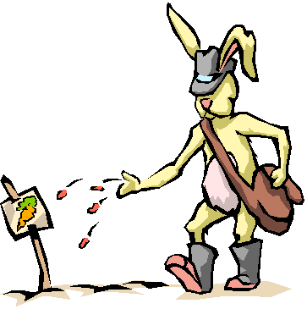

How to Make a PowerPoint Storyboard

Each group will work together to create a PowerPoint presentation on what a seed needs to grow into a healthy plant. The slide show must be a minimum of seven slides, five being different things a plant needs to grow. Before a team is allowed to begin, they must submit a Storyboard and have it approved by the teacher. The presentation must include at least the following slides:

- Title Slide
- Body Slide 1
- Body Slide 2
- Body Slide 3
- Body Slide 4
- Body Slide 5
- Credits



